Hierarchical data
Hierarchy is used for more convenient work with lists. For example, the "products" catalog usually contains hundreds of items. If it is not possible to separate these items by some categories, it will be difficult to navigate in such a list. 1C Platform allows users to create groups to place items in them, so a user can organize the data according to the structure he needs.
We can create top-level groups and nested groups to separate items as much as possible in meaning, for example:
- Food - Drinks - Sweet drinks - item
- Food - Drinks - Water - Sparkling water - item
- Parts - Engines - Some brand - item
Such a hierarchy type is called a “folder and item hierarchy”. With this type of hierarchy, a group can contain other groups and items, and an item can only be included in a group. In 1C Enterprise the group is used primarily to separate items and rarely participates in the logic of an applied solution. In such cases, the group may contain features that are common to all items included in it. Also it can be used in filter of a report, for example, we can display the sales of all products from a certain group.
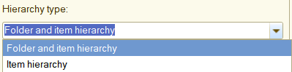
Attributes with an object type that can contain a hierarchy have a property that determines whether the value can be an element, a group, or one of the two.
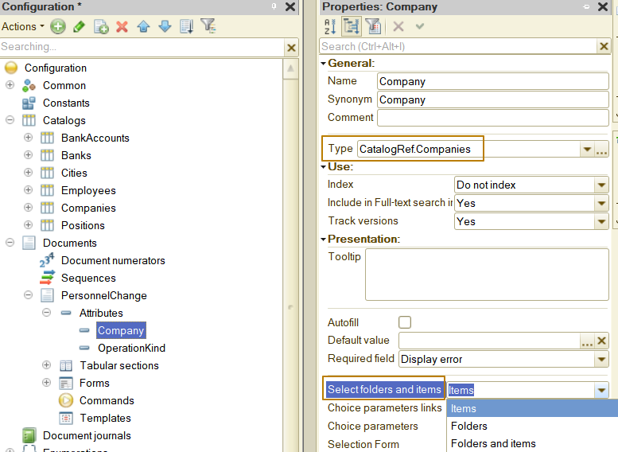

The hierarchy is supported by 2 classes of metadata: catalogs and charts of characteristic types. Hierarchy of an object can be enabled on the “Hierarchy” tab of the object's properties, as well as on the property palette:
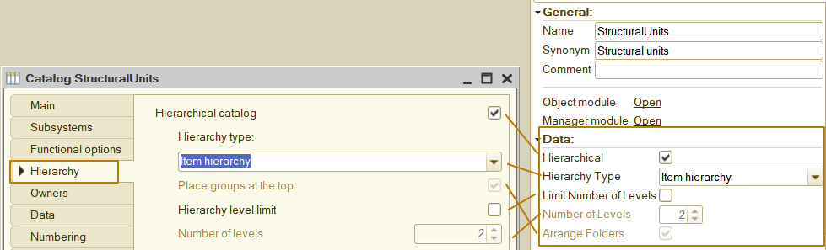
The level of the hierarchy can be limited so that users don't create overly complex data structures where they don't need to. For example, when developing a Countries catalog, it makes no sense to have many levels of hierarchy, we can limit it to the fact that the group will be a continent or part of the world, and the item will be a country. The limit defines the maximum number of group levels,which means that with a limit of 2, a user can create a group at the top level and another group inside the first one, within which only items can be created. If user tries to create a third-level group, the platform will not allow him to do this and will display an error window:
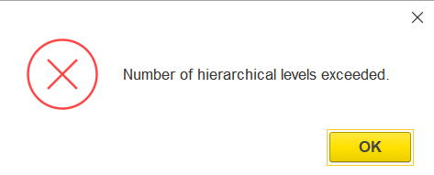
There is also another type of hierarchy - “item hierarchy”. This type of hierarchy is needed when an item can be subordinate to another item, but both of them can be selected as a value. For example, this is how the StructuralUnits catalog is arranged in many 1C applied solutions. In a large organization, there are units (divisions/departments) that are part of other units (that are part of higher units). Moreover, each unit can have employees, it can have its own plan for the coming period, so it should be possible to select both the upper and lower levels’ units as the values of some data objects.
I have created a StructuralUnits catalog and now I will add a StructuralUnit attribute to the PersonnelChange document and then output it to the document form and change its’ title to a “Department”:
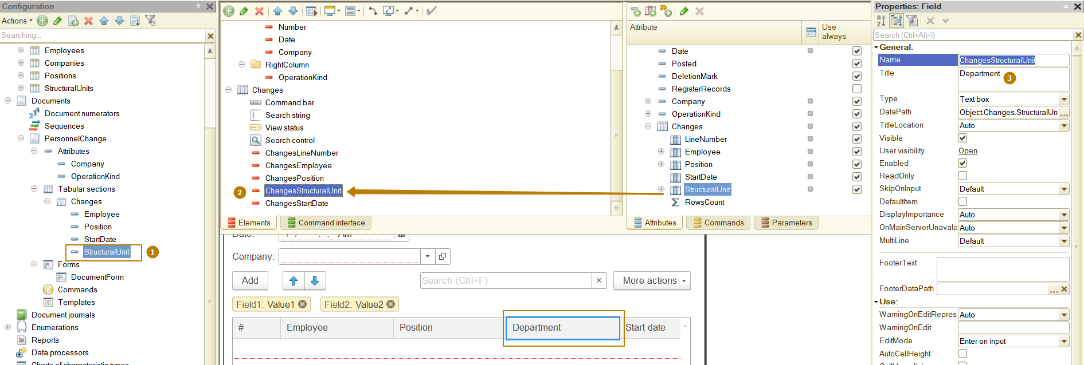
You can see that in the document I have selected both the top level item and the nested item:
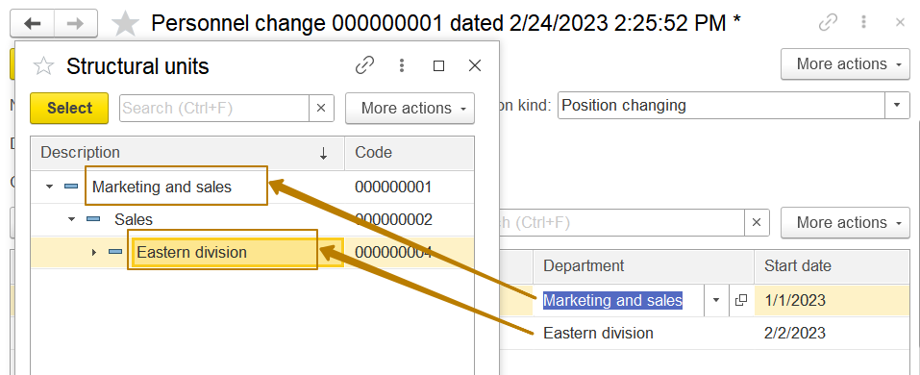
Form table can have different view modes: hierarchical list, list and tree. The list is used if user wants to see all groups and items, regardless of their location in the hierarchy.
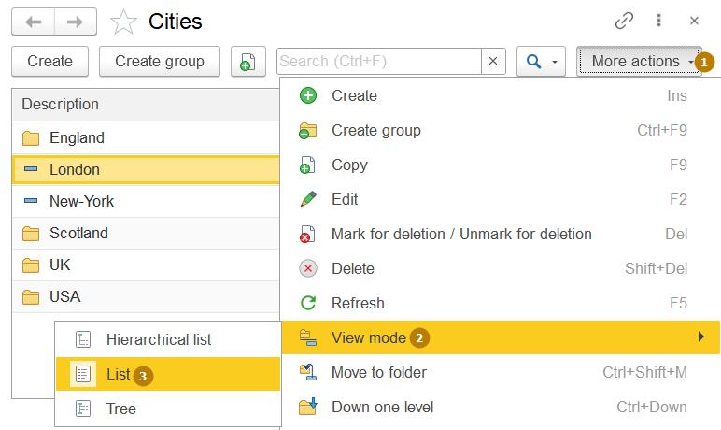
A hierarchical list, when expanding a group, displays only the groups and items included in it: 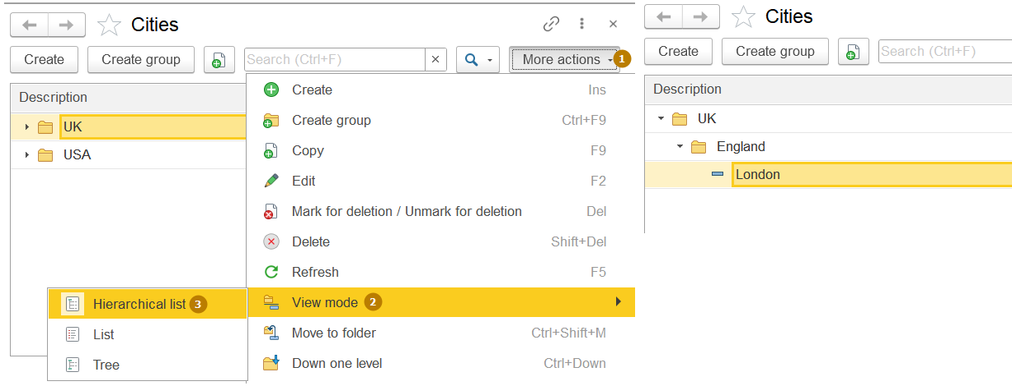
The tree displays data as nodes, user can expand each node to the bottom level
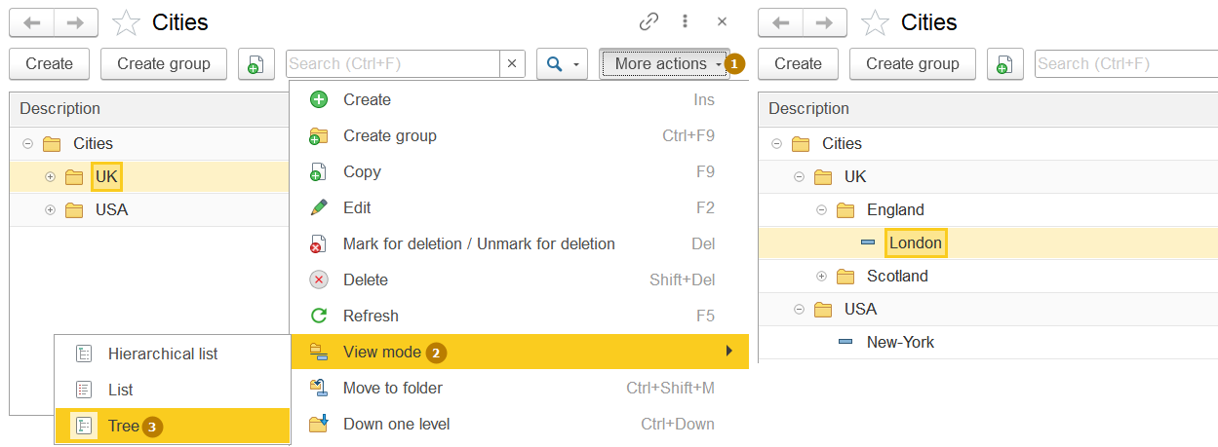
Subordination and owners
Subordination is necessary in the case when one object is semantically related to another as one to many. For example, we have a bank accounts catalog, each bank account is opened in a specific bank. An account can only have one bank it belongs to, but each bank can have any number of accounts.
Subordination in 1C:Enterprise is convenient for cases when we want to limit the user’s choice or implement a certain algorithm, depending on which object this or that item belongs to. For example, we have a Sale document, which has the fields "customer" and "contract". If we selected a customer, then it would be wrong to allow a user to select a contract with any customer, the list of contracts in this case should be limited to contracts of our organization with the selected customer.
To make an object subordinate to another, go to the Owners tab, click the edit button, and select the owner. The “use subordination” field specifies the type of object to which subordination is possible. By default, it is subordination to items.
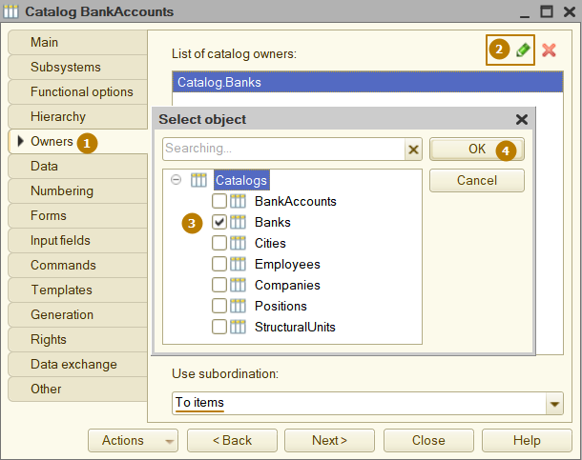
Let's take a look at the Bank accounts catalog’ item form in enterprise mode:
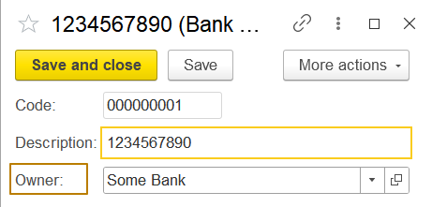
The standard attribute "Owner" has a synonym that is not very clear to the user, let's change it to "Bank":
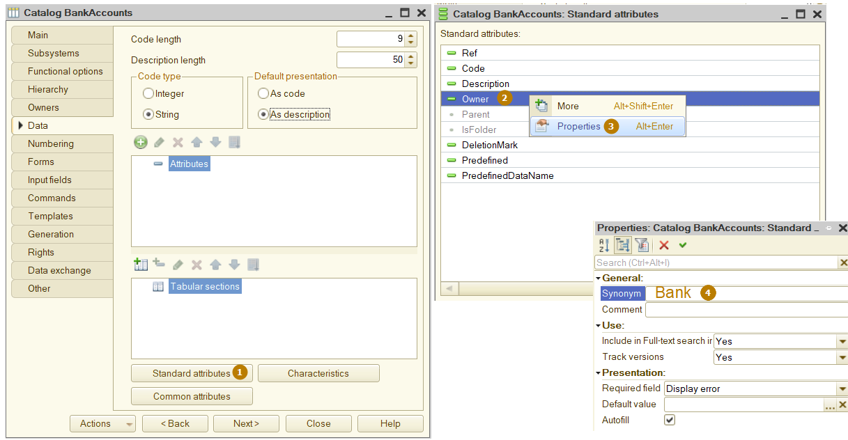
As you can see, now "Bank" is indicated not only in the field on the form, but also in the message about the requirement to fill the field (which is displayed when trying to write an object):
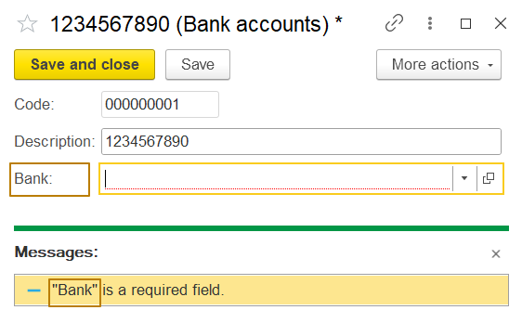
Now let's return to the task where the selection in one field must be limited by the value in another field (user is able to select a contract subordinated to selected customer).
The “Choice parameter links” property allows us to specify a list of attributes that will provide values used when a user selects an attribute value, open the choice form, display quick choice list, and upon input by row.
A Contract with the Customer can be used as an example. Firstly, the contractor is chosen, then the contract is chosen from the list of contractor contracts. The choice changes automatically when changing the contractor.
To limit the choice, the Choice parameter links property value of the attribute is set, which corresponds to the attribute name, which will be used to filter the chosen values and the attribute from which the filtering value will be taken.
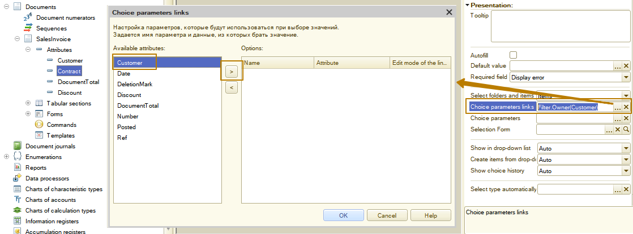
Values specified in this property will be transferred to the opened form via the Parameters structure. The Name column value will correspond to the structure element key and the attribute value stated in Attribute column - to the structure element value. If the Name column includes the ”Filter.Owner” value, the Filter form parameter will be created (Structure type). In this structure the item will be created with ”Owner” key and the value received from attribute specified in Attribute column (in the example - Customer).
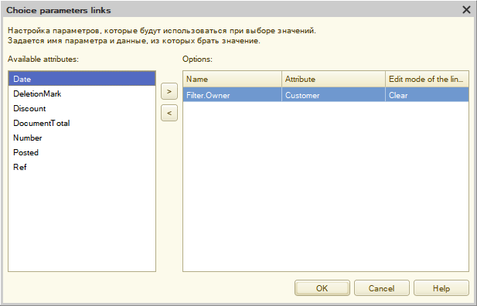
Predefined data
Earlier we got acquainted with the "Enumeration" configuration object, which has a fixed set of values that cannot be changed by the user. A directory, on the other hand, is usually maintained by the user and the elements in it are unstable - the user can change attributes, move through the hierarchy, and even delete elements of the directory. However, there are situations where it is necessary to have a certain item in the catalog from the very beginning of using the application (or since the update).
The main reason for this need is the construction of program algorithms based on predefined elements. A side effect is user friendliness, because when you start working with the application, it will already have elements that you expect to use often. Let’s take an example: we need to add to the configuration the ability to take into account the delivery of orders to customers, and delivery can be carried out both by our own and third-party services. The "Own delivery" catalog’s item must be present in the application from the moment the new functionality is added. For this purpose, the "Carriers" catalog will be created, in which we will add a predefined item.
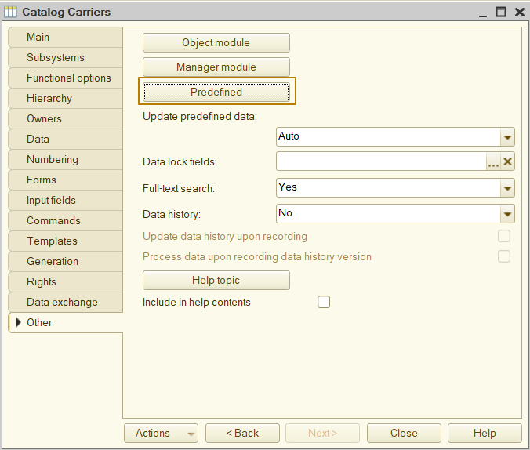
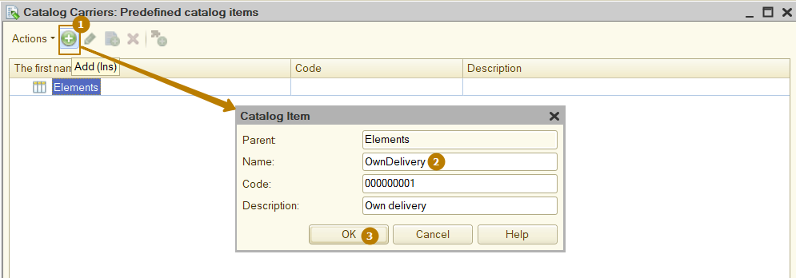
Now I will update the configuration and run the app in Enterprise mode to see the changes:
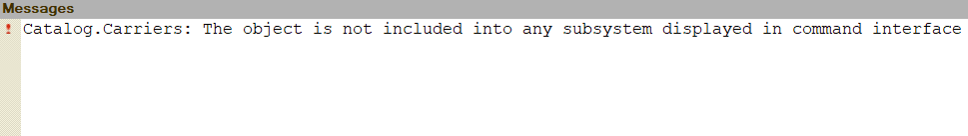
The platform reports an error again because I forgot to include the new catalog in at least one subsystem. I don't have a suitable subsystem, so I'll create a new one, name it "Sales" and include the "Carriers" catalog in it:
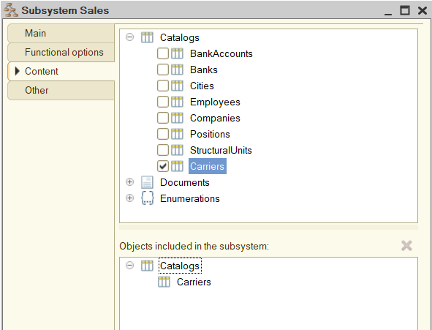
Let's finally update the configuration and run the application. The catalog appeared in the new Sales subsystem:
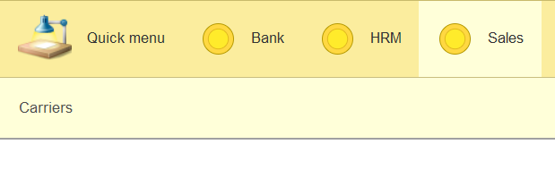
You can see that there is already one item in the list, the one we created in the configuration. Note that its icon is different from the icons of user-created elements:
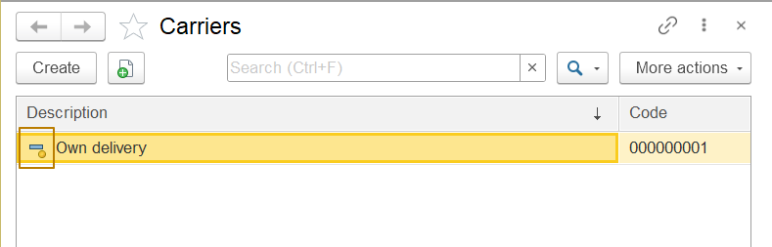
I'll create a new item to demonstrate this:
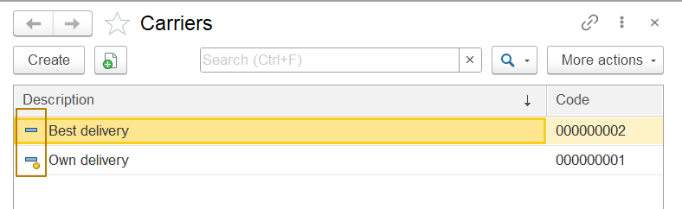
It is important to understand that a predefined item in a configuration is not a data object that users work with in Enterprise mode. A catalog contains standard attributes ‘Predefined’ (Boolean type) and ‘PredefinedDataName’ (String type) which are automatically filled in for the data object associated with the predefined item. When we add a predefined item to the configuration and update it, the platform creates a data object and associate it with the predefined item by its name:
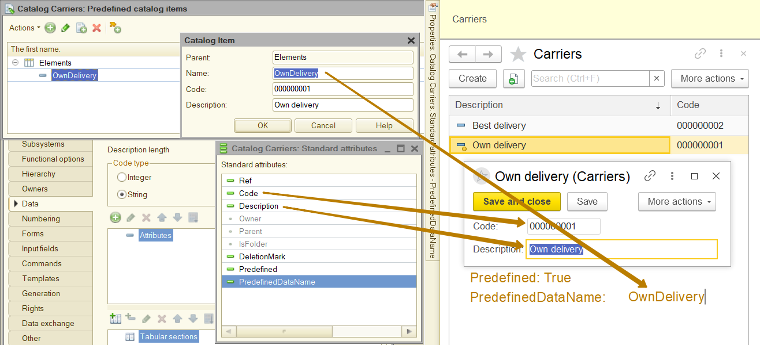
To demonstrate that a data object and a predefined configuration item are not the same, I will remove the predefined item from the configuration.
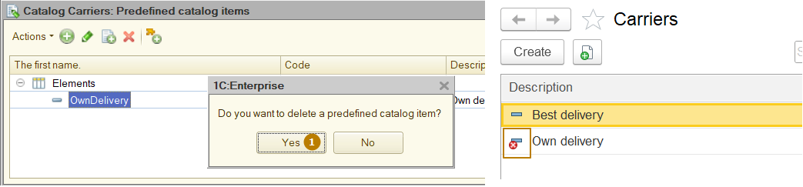
You can see that after updating the configuration, the platform has removed the connection with the predefined item (the values of the standard attributes ‘Predefined’ and ‘PredefinedDataName’ have changed: ‘Predefined’ = False and ‘PredefinedDataName’ = “”), now the icon in the list corresponds to the icon of a regular catalog item. The data object has also been marked for deletion.
Now I will create the same predefined item again. The platform re-created the data object and associated it with the predefined item because the previous data object was already unlinked:
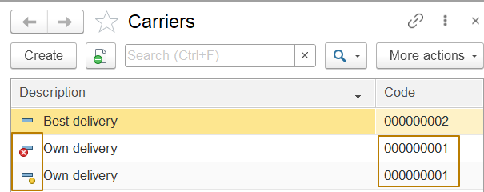
An object associated with a predefined item can be accessed from the code by its name (Name of the predefined item), in our example, I can write a condition to check if a delivery method is by our own delivery.
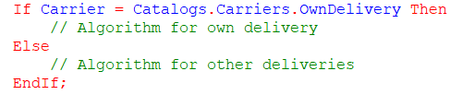
We could find a data object that is not associated with a predefined item, for example, by code or description - there are methods for this in the 1C language. But it is better not to build an application operation algorithm on unstable data, since the user can change or even delete it at any time.
Code, number, auto numbering
Previously, we have already considered the standard attributes "code" of the catalog and "number" of the document. Let's deal with them in more detail, and also find out what auto-numbering is. In general, the standard attribute "code" is present not only for the Catalogs class, it is also present for the metadata classes Charts of characteristic types, Charts of accounts, Charts of compensation types (we will get to know some of these metadata classes later).
"Code" and "number" are attributes that allow us to control the uniqueness among all or some data objects within the metadata object.
Let's take a look at the catalog’s “Numbering” tab:
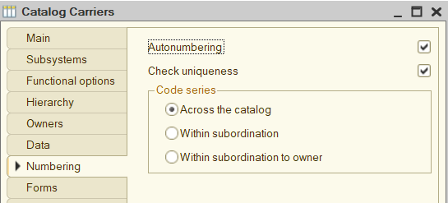
The auto-numbering property is responsible for whether the code will be automatically assigned by the platform when writing a new data object. If the property is enabled, the platform also changes the behavior of the field on the form - it looks unavailable for editing, and if a user tries to edit it manually, the platform gives a warning to a user. If the property is disabled, a user must fill in the code manually.
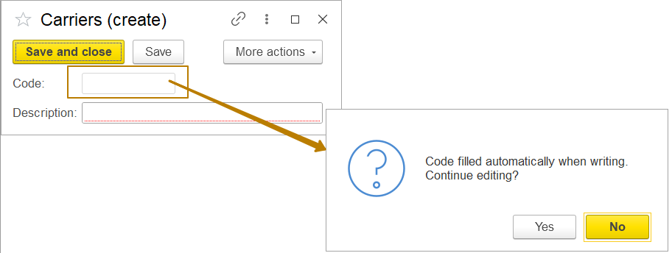
The next property, “check uniqueness”, is responsible for whether the platform will control the uniqueness of the code when writing a data object in the specified directory. If the code is not unique, the platform will report an error:
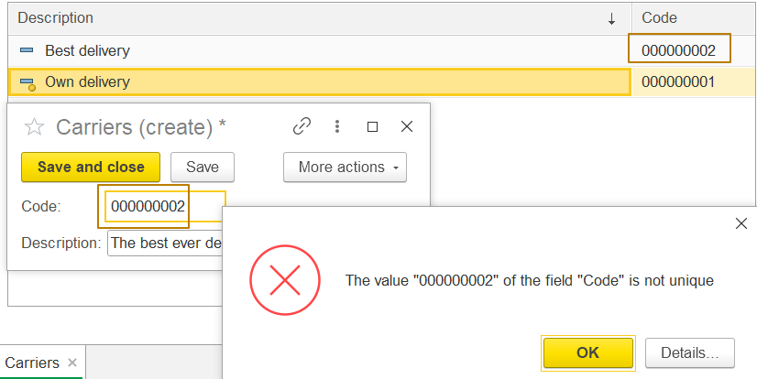
The “code series” property with three options only makes sense if at least one of the two previous properties is enabled and it changes the logic of how these properties work. Let's consider the influence of the selected option of this property on the behavior of the platform when the “auto-numbering” or/and “check uniqueness” properties are enabled:
Code series | Auto-numbering | Check uniqueness
Across the catalog | One is added to the maximum code in order among all catalog items (for example, after the code A00000019 there will be the number A00000020) | The uniqueness of the code is checked among all catalog items
Within subordination | One is added to the maximum code in order among the items of the current parent (catalog items with different parents can have the same code) | The uniqueness of the code is checked among items of the current parent
Within subordination to owner | One is added to the maximum code in order among the items of the current owner (catalog items with different owners can have the same code) | The uniqueness of the code is checked among items of the current owner

Let's move on to the document number and start with the “Numbering” tab:
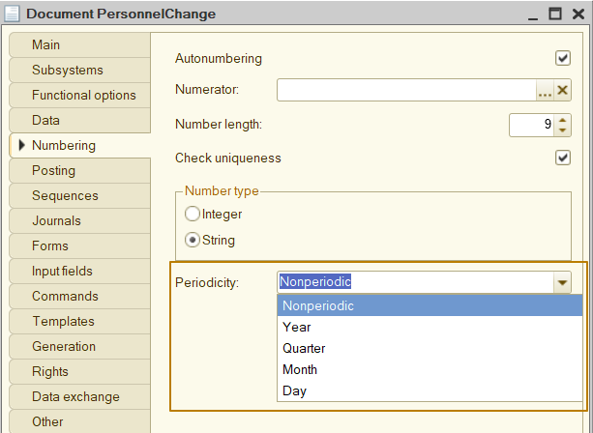
we can see that many of the properties are fully or partially the same as the properties of the catalog, only for the catalog some of the properties associated with the code are located on the "Data" tab:
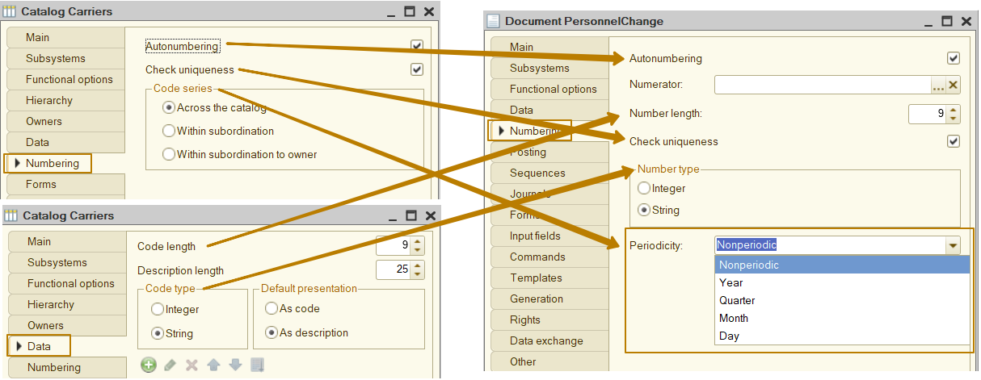

Let's take a look at the different document properties:
- "Periodicity" is intended to specify the period within which document numbers must be unique. For many primary documents, such as an purchase invoice or sales invoice, the document number must be unique within a year - each year the first entered document is numbered from 1. The "Nonperiodic" option means that document numbers must not repeat, regardless of its date.
- “Numerator” property allows us to select an object of the "DocumentNumerator" type in order to organize a uniform numbering of documents, for example, you can create a "Personnel" numbering to number all personnel orders the same.
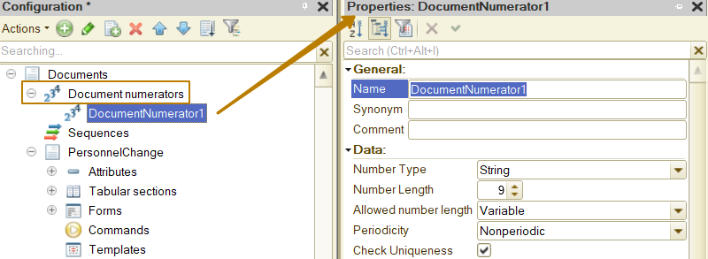
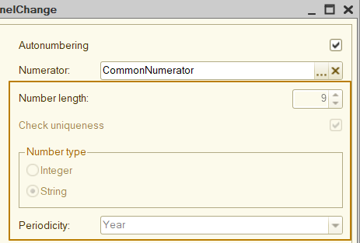
When a numerator is selected, all properties, except for “Autonumbering”, are filled from the numerator and become disabled for editing.

There are situations when a catalog does not need code at all, for example, a catalog of document states: "draft", "under approval", etc. In such a catalog, a description uniqueness check can be implemented so that there are no two identical "draft" states, but the code does not bring any benefit at all - the states do not need to be searched or distinguished by code. The use of code in the catalog can be disabled by specifying 0 as its length, in which case the standard "code" attribute and the "code type" property will become unavailable:
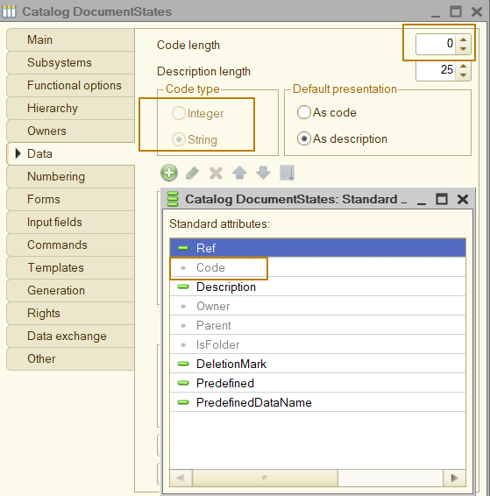
The document number can be disabled in the same way, but this rarely makes sense.

